INFORMATION TECHNOLOGY SHIP TRADING

SHIP TRADING

*Submitted by*

**1. SARIKA J. VEKARIYA (120430116016)**

**2. ISHA S. KORAT (120430116039)**

*In fulfilment for the award of the degree*

*Of*

**BACHELOR OF ENGINEERING**

*In*

**INFORMATION TECHNOLOGY**

*Guided By*

***Prof. Disha Shanghani***



**SUBMITTED TO:**

**SHANTILAL SHAH ENGINEERING COLLEGE, SIDSAR, BHAVNAGAR**

**GUJARAT TECHNOLOGICAL UNIVERSITY, AHMEDABAD**

**October 2016**

INFORMATION TECHNOLOGY SHIP TRADING



**INFORMATION TECHNOLOGY ENGINEERING**

**NOVEMBER 2016**



***--------------CERTIFICATE-----------------***

Date :

This is to certify that the dissertation entitled **“SHIP TRADING”** has been carried out by **Vekariya Sarika J.** under my guidance in fulfilment of the degree of Bachelor of Engineering in **Information Technology(8th Semester)** of Gujarat Technological University, Ahmadabad during the academic year 2015-16.

**Guided By : Head of Department**

**Prof. Disha Shanghani**

INFORMATION TECHNOLOGY SHIP TRADING



**INFORMATION TECHNOLOGY ENGINEERING**

**NOVEMBER 2016**



***--------------CERTIFICATE-----------------***

Date :

This is to certify that the dissertation entitled **“SHIP TRADING”** has been carried out by **Korat Isha S.** under my guidance in fulfilment of the degree of Bachelor of Engineering in **Information Technology(8th Semester)** of Gujarat Technological University, Ahmadabad during the academic year 2015-16.

**Guided By : Head of Department**

**Prof. Disha Shanghani**

INFORMATION TECHNOLOGY SHIP TRADING

**INDEX**

|  |  |  |
| --- | --- | --- |
| **No.** | **Topic** | **Page No.** |
| **1.** | **Introduction** | **10** |
|  | 1.1 Project Profile | 11 |
|  | 1.2 Project Aim | 12 |
|  | 1.3 Project Definition | 12 |
|  | 1.4 Project Scope | 12 |
|  | 1.5 Open source Module Detail | 12 |
| **2** | **Project Management** | **15** |
|  | 2.1 Project Planning | 16 |
|  | 2.2 Risk Management | 16 |
|  | 2.3 Process Model :The incremental Model | 17 |
| **3** | **System Requirement Study** | **20** |
|  | 3.1 User Characteristics | 21 |
|  | 3.2 Hardware and Software Requirements | 21 |
| **4** | **System Analysis** | **22** |
|  | 4.1 Problem & Weakness of current system | 23 |
|  | 4.2 Requirement of new System | 23 |
|  | 4.3 What is PHP? | 24 |
|  | 4.4 Why use PHP? | 24 |
| **5** | **System Design** | **25** |
|  | 5.1 Context Diagram | 27 |
|  | 5.2 E-R Diagram | 27 |
|  | 5.3 Data flow Diagram | 29 |
|  | 5.4 Class Diagram | 36 |
|  | 5.5 Use-case Diagram | 38 |
|  | 5.6 Data Dictionary | 38 |
| **6** | **Testing** | **42** |
|  | 6.1 Introduction | 43 |
|  | 6.2 Testing Plan | 43 |
|  | 6.3 Testing Principals | 45 |
|  | 6.4 Testing Strategy | 45 |
|  | 6.5 Test case | 47 |
|  | 6.6 Testing on admin login | 47 |
| **7** | **Screen Shots** | **48** |
|  | 7.1 Login Page | 49 |
|  | 7.2 Register Page | 49 |
|  | 7.3 Home Page | 50 |
|  | 7.4 Service Page | 50 |
|  | 7.5 Add rate Page | 51 |
|  | 7.6 Tide-Table Page | 51 |
|  | 7.7 Shop page | 52 |
|  | 7.8 Faq page | 52 |
|  | 7.9 News page | 53 |
|  | 7.10 Contact us page | 53 |
|  | 7.11 Buy page | 54 |
|  | 7.12 Order review Page | 54 |
| **8** | **Application Features** | **55** |
| **9** | **Limitation and Enhancement** | **57** |
|  | 9.1 Limitation | 58 |
|  | 9.2 Enhancement | 58 |
| **10** | **Conclusion & References** | **59** |

INFORMATION TECHNOLOGY SHIP TRADING

**LIST OF FIGURES**

|  |  |  |
| --- | --- | --- |
| **Fig No.** | **Fig Name** | **Page No.** |
| 2.3 | Increment Model | 18 |
| 5.1 | Context Diagram | 27 |
| 5.2 | E-R Diagram | 29 |
| 5.3 | Data Flow Diagram | 29 |
|  | 5.3.1 First level DFD for Buyer | 31 |
|  | 5.3.2 First level DFD for seller | 32 |
|  | 5.3.3 First level DFD for admin | 33 |
|  | 5.3.4 Second level DFD for Buyer | 34 |
|  | 5.3.5 Second level DFD for Seller | 35 |
| 5.4 | Class Diagram | 37 |
| 5.5 | Use-case Diagram | 38 |

INFORMATION TECHNOLOGY SHIP TRADING

**LIST OF TABLES**

|  |  |  |
| --- | --- | --- |
| **Table No** | **Table Name** | **Page No** |
| 5.6 | 5.6.1 Register | 39 |
|  | 5.6.2 Admin | 39 |
|  | 5.6.3 Contact | 40 |
|  | 5.6.4 Product | 40 |
|  | 5.6.5 Faqs | 41 |
|  | 5.6.6 News | 41 |
|  | 5.6.7 Tide-table | 41 |

INFORMATION TECHNOLOGY SHIP TRADING

**ACKNOWLEDGEMENT**

Every work that one completes successfully sends on the constant encouragement, good will and support of the people around. I, hereby, avail this opportunity of express my heartfelt gratitude to a number of people who extended their valuable time, full support and co operation and developing this project.

I owe deep gratitude to a number of people who have guided, inspired and motivated me. So I take this opportunity to thank all of them. This endeavor of me has given me insight into the various aspects of the software implementation in practical applications. It has given me a hand on experience, which I could not have gained from all the books of the world.

Proper organization of concept and analysis of the system is due to keep interest and helping hand of our teachers and colleagues. We are deeply thankful to Prof. B.V.Buddhadev Sir Head of department, who was a constant source of inspiration during this project.

We are also greatly thankful to entire computer laboratory staff that has helped us in completion of this project directly or indirectly.

INFORMATION TECHNOLOGY SHIP TRADING

**ABSRACT**

A program is known as Ship Trading. In this website introduce a **ALANG** and how replace all ship salvaged around the world. This system is work on online selling and purchase of all internal part of ship and ship material. It also maintain record of all details with much security. In this website all business person get all idea about ship trading who want to buy material of ship without third party and also create online auction. Many businesses, more people and more utilities are putting together at one platform and built a new online platform for or kind of activities related with Alang Shipyards.

**1.INTRODUCTION**

* 1. **Project Profile:**

“Ship Trading” System is a Website developed in PHP language. The main aim of “Ship Trading” is provided daily information of Alang Shipyard and know daily rate of all material of Alang without third person.

The primary features of project “Ship Trading” are high accuracy, design, flexibility and availability. And also it uses database tables representing entities relationship between entities.

**Project Title**  **:** Ship Trading

**Project Type :** Web base Application

**Objectives :** To develop a web base application

**Technology :** PHP

**Organization :** Bhaskaracharya Institute For Space Application

& Geo-informations (BISEG), Gandhinagar.

**Purpose :** B.E.IT(8th semester).

**Back-end tools :** Ms. SQL Server 5.6.12.

**Internal Guide :** Prof. Disha Sanghani

**Developed By :** Vekariya Sarika(120430116016)

Korat Isha(120430116039)

**1.2 Project Aim:**

Ship Trading is a open source is design and develop to provide better information to the buyer of Alang Ship Yard, they can aware all information related to Alang Shipyard like daily rate of Scrapping, Melting, Ingode and other Raw-Material of Alang.

**1.3 Project Definition**:

Ship Trading is a website which main aim is to provide accurate information to the buyer who buy a Raw-Material from Alang and easy communication with buyer.

**1.4 Project Scope:**

Software scope describe the function and features that are to be deliver to the end –user. This project provide details like daily news, daily current rate of melting, scrapping , Alang detail , news update and get required information. System have administration authentication, admin can change the modules, update modules, create authentication.

**1.5 Open Source Module Detail:**

Problem Decomposition Elaboration with Justification (Module wise).

**Front end (Customer Module)**

* **Buyer**
* User Registration
* User Login
* View/Update Profile
* Search Material
* Buy Material
* **Seller**
* User Registration
* User Login
* View Profile
* Search Material
* Sell Material
* **Registration**
* Taking User name
* Taking Password
* Taking Confirm Password
* Taking First name
* Taking Last name
* Taking Gender
* Taking Address
* Taking Category
* Taking City
* Taking State
* Taking Country
* Taking Email Address
* **Login**
* Taking Username
* Taking Password
* **Buyer’s Area**
* **View/Update Profile:**

When search is found then desired user can’t see regarding information register themselves first.

* **Search Material:**

Taking Input values like different material of ship yard and display them on screen if no such is available then a message is appeared on the screen.

* **Buy Material:**

Buyer can buy his/her interested materials from the websites.

**Back end(Administrative Module)**

* Login
* Managing User account
* Update news
* Update Product of Alang
* Update Gallery
* Update Faqs
* Client side module deals with the Detail of All pages related activity like Home Page, About us page, Services, Faqs, Shop and contact us page etc.
* Admin is the hand of the system which basically deals with the all modules.
* The home page contain several information about Alang like Alang Scrapping, Alang Melting, Alang ingode, Daily news, Tide table etc.

**2.PROJECT MANAGEMENT**

Project Management is an important part of project development. It deals with all the main area for project development like feasibility, Requirement analysis, Project Schedule, Project Plan etc. We have used the Project management approach to deal with all the areas.It is achieved by proper selection of software Life Cycle Model.

**2.1 Project planning:**

Project planning and scheduling donned through like first gathering all data and requirement of the project and then making planning for how to describe that data and how to manage the data. All required data is gathered from Alang Shipyard like Tide table of daily rate and differences. Then Planning is done how to describe and manage that all data which provide more benefits to all users.

**2.2 Risk Management:**

**Technology Risk:**

The database use in the system cannot process as many transactions per second as expected. Software components that should be reused contain defect that limit their functionality.

**People Risk:**

Ship Agent managers , workers have to ready for new changes their response towards to the system have to positive.

**Institute Risk:**

Alang is restructured so that different category management is responsible for the System.

**Requirement Risk:**

Changes to requirement that requires major design rework are proposed. Customers fail to understand the impact of requirement change.

**Estimation Risk:**

The time required to develop the software is underestimated. The size rate of detect repair is underestimated. The size of software is underestimated.

**2.3 Process Model: The Incremental Model**

We have completed our project by increments as listed below:

**Core Application:**

The basic functionality we have approached are to analysis our projects.

**Increment 1:**

We have implemented from designing modules as our first increments.

**Increment 2:**

Then we have expanded the user requirements to the query level by allowing him/her to fire queries on current system.

**Increment 3:**

Finally we are toughly concentrating for the testing and validation in modules, we succeeded at the end by imposing them on.

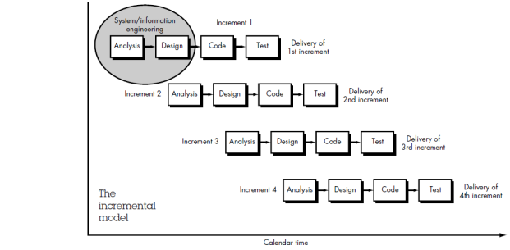

**Fig.2.3.1 Incremental Model**

Incremental model is an evolution of waterfall model. The product is design, implemented, integrated and tested as a series of incremental builds. It is a popular model software evolution used many commercial software companies and system vendors.

**1. System/Information engineering and modeling:**

System engineering and analysis encompass requirements gathering the system level with a small amount of top-level design and analysis. Information engineering encompasses requirements at the strategic business level and the business area level.

**2. Software requirements analysis:**

The requirement gathering process is intensified and focused specifically on software. Software requirement analysis encompasses understanding the information domain for the software as well as required functions, behavior, performance and interfacing. Requirements for both the system and the software are documented and reviewed with the customer.

**3. Design:**

Software design is actually a multi-step process that focuses on four distinct attributes of a program: data structure, Software architecture, interface representation and procedure detail. The design process translates requirements into representation of the software that can be access for quality before coding begins.

**4. Code Generation:**

Code-generation phase translates the design into a machine-readable form.

**5. Testing:**

Once code has been generated, program testing begins. The testing process focuses on the logical internals of the software, ensuring that all statement have been tested, and on the functional externals, that is , conducting tests to uncover errors and ensure that defined input will produces actual results that agree with required results.

**6. Maintenance:**

Software maintenance applies to following phases in the existing program change in software due to errors. Change in software because the software must be adapted to accommodate changes in its external environment. Changes in software when the customer requires functional or performance enhancements.

**3.SYSTEM REQUIREMENT STUDY**

**3.1 User Characteristics:**

There are two users that dealing with the system:

1. Admin
2. Buyer
3. Seller

This is user which may be technical or non-technical by nature. He / She may not be known to surfing websites and downloading etc. or may be highly sophisticated software developed too. We are to concentrate about those of non-technical ones. We are providing GUI clicks on link or buttons would make their tasks easier and checkbox and image buttons which would specify the purpose of it itself. Admin and User is responsible for mainlining database and updating in System.

**3.2 Hardware and Software Requirements:**

1. **Platform :** PHP 5.2.8
2. **Client OS** **:** Windows 8
3. **Client Authoring** **:** XHTML, Java script, CSS
4. **Code Behind** **:** Java script, PHP, HTML
5. **Web Server** **:** Wamp Server
6. **Development Tool**   **:** Active state komodo edit 7.1
7. **Version and Source Control**  **:** Active state komodo edit 7.
8. **Back-end Tools** **:** MS SQL Server 5.1.30
9. **A & D/UML :** Ms office world, Wow slider

**4.SYSTEM ANALYSIS**

System analysis is the process of gathering and interpreting facts, diagnosing problems and using the information to recommended improvements on the systems. System analysis is a problem solving activity that requires intensive communications between the system users and system developers.

System analysis or study is an important phase of the system development process. The system is studied to minutest detail and analyze. The system analyst plays the role of an interrogator and dwells deep into the working of present system. The system is viewed as a whole and the inputs to the system to identified. The output from the organization are traced through as various processing that the input phase through in the organization.

A detail Study of these processes must be made by various techniques like Interviews, Questioners etc. The data collected by these sources must be scrutinized to arrive to a conclusion. The conclusion is an understanding of how the systems functions. This system is called existing system. Now, the existing system is subjected to close study and the problems are identified. The designer now functions as a problem solver and tries to sort out the difficulties that the enterprise faces. The solution are given as proposals. The proposals is presented to the user for an endorsement by the user. The proposal is reviewed on user request and suitable changes are made. This loop ends as soon as the user is satisfied with a proposals.

**4.1 Problems and weakness of current Systems:**

The existing website is dynamic but is less interactive. Moreover user didn’t have an access to the details of the Alang through the site, the GUI problems hence they were not update about the latest news, User can’t get all details. All detail is not updated.

**4.2 Requirement of new System:**

In order to make the site dynamic and more interactive it is provide better GUI, we have tried to include a database link to our website. Hence the recruiters have been provided with facility to post their eligibility criteria Provision has also been made to display the latest news the online.

**4.3 What is PHP?**

PHP is a programming language for building a dynamic, iterative websites. As a general rule, PHP program run on the web server, and serve web pages to visitors on request. One of the key features of the PHP is that you can embed PHP code with HTML web pages, making it very easy for you to create dynamic content quickly.

What exactly does the phrase “dynamic iterative website” mean? A dynamic website is a page whose content can change automatically each time page is viewed. Contrast this with a static web page, such a simple HTML file, which looks the same each time it is display. Meanwhile, an iterative web site is a site that responds to input from its visitors. A web forum is a good example – user can post new message to the forum.

**4.4 Why use PHP?**

One of the best thing about PHP is the large number of Internet Service Provider (ISP) and web hosting companies that support it. Today hundred of thousand of developers are using PHP, and it’s not surprising that there are so many, considering that several million sites are reported to have PHP installed.

Another great feature of PHP is that cross platform – you can run on PHP programs on window, Linux, FreeBSD, Mac OS X, and Solaris among others.

What’s more, the PHP engine can integrate with all common Web servers, including Apache, Internet Information Server, Zeus.

This mean that you can develop the test your PHP web sites on the setup, then deploy it on a different type of system without having to change much of your code. Furthermore, it’s easy to move your PHP websites onto other server platform, if you ever need to.

**5. SYSTEM DESIGN**

System design is the solution to the creation of a new system. This phase is composed of several Systems. This phase focuses on the detailed implementation of the feasible system. It emphasis on translating design specifications to performance specifications. System design has two phases of development logical and physical design.

During logical design phase the analyst describes input (sources), out puts (destinations), data store (data flow) all in a format that meats the user requirements. The analyst also specifies the user needs and at a level that virtually determines the information flow into and out of the system and the data resources. Here the logical design is done through flow diagram and design database.

The physical design is followed by physical design or coding. Physical design produces the working system by defining the design specifications, which tell the programmer exactly what the candidate system must do. The programmer write the necessary program that accept input from the user, perform necessary processing on accepted data through call and procedure the required report on a hard copy or display it on the screen.

**5.1 Context Diagram:**



**Fig. 5.1 context diagram**

**5.2 Entity Relationship Diagram:**

People, Places and Things are used into the system. This is known as entity of the system. This entity is interacting with other in various ways and that interaction is called entity relationship. In this system analyst is one of the conceptually modeling methods. This method was first introduced by Chen in 1976 and now widely used.

E-R diagram is used to show the relationship among the entities. Entity and Table level ER Diagram is used from this relationship.

Here I am use Table-level ER diagram to show the relationship between more than two tables.

ER diagram contains symbols to representing design view for relationship among the Entities.

1. **Entity:**

An Entity is a person , Place or thing in an enterprise. For example, A customer an employee, a project an order etc. Similar objects or things are grouped into entity sets. Thus a collection of customers is customer entity set.

1. **Relationship:**

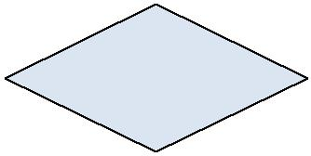A relationship a meaningful association or linkage or collection between entities. Symbol used

Types of relationship

* One-one Relationship
* One-N Relationship
* Many-Many Relationship

1. **Attributes:**

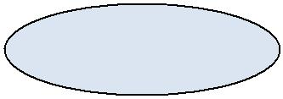

An attributes is any aspect, quality, characteristics, or either of an entity or a relationship. An attributes tells what an entity is, entity has, entity contain. For e.g. the entity car is of a particular make and year has speed, comforts, contain the tires, engine etc. does carry people, race etc. are attributes.

Below ER diagram represents the relationship between tables. Table name is an entity and table field is an attributes of table.

Tide Table

Upload

Purchase for

News

User

Reqg

Reg.

Has

Register

Request

Image

Has

**Fig.5.2 ER Diagram**

**5.3 Data Flow Diagram:**

The data flow diagram is one of the most important modeling tools used by system analysis. The use of data flow diagram as modeling tools was populated by Demarco (1978) through their structure. System analysis methodologies

They suggested that a data flow diagram should be first tool used by the system analysis to odel system components. These components are the system processes, the data used by system analysts to model system these processes.

**Data flow diagram symbols:**

**Data flow:**

Data move in a specific direction from an origin to a destination in the form of documents. letters, telephones or virtually any other mediums. The data flow is a “Packet of data”.

**Processes:**

In this people, procedures or devices that use or produce data. The physical components are not identified.

**Source and Destination:**

External source or destination of data, which may be people, programs, organizations and other entities interact with system but data are outside its boundary.

**Data store:**

Data are stored or referenced by a process in the system. The data store may represent computerized or non computerized devices. Each components in a data flow diagram is labeled with a descriptive name. Process names are further identified with a number that will be used for identification purpose. The number assign to a specific process does not represent the sequence of processes. It is strictly used for identification and will take on added value to the components that make up a specific process.

**5.3.1First Level diagram for buyer**



**Fig.5.3.1 First level diagram for buyer**

**5.3.2 First level diagram for seller:**



**Fig.5.3.2 First level diagram for seller**

**5.3.3 First Level diagram for Admin:**



**Fig.5.3.3 First level diagram for Admin**

**5.3.4 Second Level diagram for Buyer:**



**Fig.5.3.4 Second level diagram for Buyer**

**5.3.5 Second Level diagram for Admin:**



**Fig.5.3.5 Second level Diagram for Admin**

**5.4 Class Diagram:**

The class model represents the static, structural data aspects of a system. The class model describes the structural of object in a systems – their relationship to other objects, their attributes and their operations. The class model provide context for the state and interaction Model.

**Objects:**

The purpose of class model is to describe objects, abstract or thing with identified that has meaning for an applications. Some objects have real world counter parts, with other are conceptual.

**Classes:**

A class describe a group of objects with same properties, behavior, kinds of relationship and semantics. The choice of classes depends on the nature and is a matter of judgments. Objects grouped in class each objects knows its class.

**Operations and methods:**

An operation is a function or procedures that may be applied to or by object in a class. Each operation has target objects as implicit arguments. The behavior of operations depend on the class of its target. An object knows its class and hence the right implementation of the operations.

**Links and associations:**

A link is a physical connection of objects. Most link relates two objects but some link relates three or more objects. A link is instance of an associations. An association describes of a group of links with common structure and common semantics. An associations describes a set of potential link in the same way that a class describes a set of potential objects. Links and associations often appear as verbs in a problem statement.

**Generalizations:**

Generalization is the relationship between a class (the super class) and one or more variations of class (the sub class). Generalization organize classes by their similarities and differences structuring description of objects.



**Fig.5.4.1 Class diagram of class name and objects**

**5.5 Use case Diagram:**

Buyer

Admin

Seller

**Fig.5.4.1 Use case Diagram**

**Fig.5.5.1 Use case Diagram**

**5.6 Data dictionary:**

**List of tables:**

* Registration
* Admin
* Contact Detail
* Product
* Faqs
* News
* Tide-Table

**5.6.1 Register [This table used to register user(sell/buyer)];**

|  |  |  |  |
| --- | --- | --- | --- |
| **Field** | **Comment** | **Data** **Type** | **Constraints** |
| Used | To identify the user | Int | Primary Key |
| Fname | First Name | Varchar(20) | Not Null |
| Lname | Last Name | Varchar(20) | Not Null |
| Email | Email Address | Varchar(35) | Not Null |
| Mobile | Mobile No. | Varchar(14) | Not Null |
| City | City | Varchar(20) | Not Null |
| State | State | Varchar(20) | Not Null |
| Country | Country | Varchar(20) | Not Null |
| Pincode | Pincode | Varcare(10) | Not Null |
| Address | Address | Varchar(255) | Not Null |
| Category | Category | Varchar(20) | Not Null |
| Gender | Gender | Varchar(6) | Not Null |
| Password | Password | Varchar(10) | Not Null |
| Image | Image | Varchar(100) | Not Null |

**5.6.2 Admin [This table contain Admin login information]:**

|  |  |  |  |
| --- | --- | --- | --- |
| **Field** | **Comment** | **Data** **Type** | **Consraints** |
| Aid | To identify the user | Int | Primary Key |
| Email | Email | Varchar(35) | Not Null |
| Password | Password | Varchar(10) | Not Null |

**5.6.3 Contact [This information contain contact information];**

|  |  |  |  |
| --- | --- | --- | --- |
| **Field** | **Comment** | **Data** **Type** | **Constraints** |
| cid | To identify the user | Int | Primary Key |
| Cname | Name | Varchar(20) | Not Null |
| Email | Email | Varchar(35) | Not Null |
| Mobile | Mobile | Varchar(14) | Not Null |
| Subject | Subject | Varchar(25) | Not Null |
| Message | Message | Varchar(255) | Not Null |

**5.6.4 Product:**

|  |  |  |  |
| --- | --- | --- | --- |
| **Field** | **Comment** | **Data** **Type** | **Constraints** |
| Pid | To identify the user | Int | Primary Key |
| Ptitle | Name | Varchar(15) | Not Null |
| SKU | Mobile | Int(20) | Not Null |
| Pdescription | Message | Text | Not Null |
| Pcategory | Email Id | Varchar(25) | Not Null |
| Price | Subject | Int(5) | Not Null |
| Shipping_charge | Shipping Charge | Varchar(10) | Not Null |
| Qty | Quntity | Int(3) | Not Null |
| Stock | Stock | Int(1) | Not Null |
| Image_1 | Image | Varchar(100) | Not Null |
| Status | Status | Int(1) | Not Null |

**5.6.5 Faqs:**

|  |  |  |  |
| --- | --- | --- | --- |
| **Field** | **Comment** | **Data** **Type** | **Constraints** |
| Fid | To identify the user | Int | Primary Key |
| Question | Question | Varchar(255) | Not Null |
| Answer | Answer | Varchar(500) | Not Null |

**5.6.6 News:**

|  |  |  |  |
| --- | --- | --- | --- |
| **Field** | **Comment** | **Data** **Type** | **Constraints** |
| Nid | To identify the user | Int | Primary Key |
| Title | Name | Varchar(300) | Not Null |
| description | Message | Text | Not Null |
| Date | Email Id | Varchar(11) | Not Null |
| Image | Subject | Varchar(100) | Not Null |

**5.6.7 Tide-Table detail:**

|  |  |  |  |
| --- | --- | --- | --- |
| **Field** | **Comment** | **Data** **Type** | **Constraints** |
| Tid | To identify the user | Int | Primary Key |
| Usid | User id | Int(11) | Not Null |
| Category | Category | Varchar(10) | Not Null |
| Product_type | Product Type | Varchar(20) | Not Null |
| Pdescrption | Description | Varchar(255) | Not Null |
| Price | Price | Int(7) | Not Null |
| Quantity | Quntity | Int(5) | Not Null |
| Date | Date | Varchar(30) | Not Null |

**6. TESTING**

**6.1 Introduction:**

The aim of the testing process is to identify all defects existing in a software product. Testing a program consists of subjecting the program to as set of test inputs (or test cases) and observing if the program behaves as expected. If the program fails to behave as expected, then the conditions under which failure occurs are noted for later debugging and correction. The following are some commonly used terms associated with testing

* A **failure** is a manifestation of an error (or defect or bug). But the mere presence of an error may not necessarily lead to a failure
* A **test case** is the triplet [I, S, O], where I is the data input to the system, S is the state of the system at which the data is input, and O is the expected output of the system
* A **test suite** is the set of all test cases with which a given software product is to be tested.

**6.2 Testing plan**

Once source code has been generated, software must be tested to uncover as many errors as possible before delivery to your customer.

Software tested from two different perspectives:

* Internal program logic is exercised techniques.
* Software requirements are exercised using both cases, the intent is to find maximum number of error with minimum amount of effort and time.

Attributes of good tests are :

* A good test has high probability of finding an error.
* A good test is not redundant.
* A good test should be “best of breed”.
* A good test should be neither too simple nor too complex.

**6.3 Testing Principals.**

Before applying method to design effective test cases, a software engineer must understand the basic principle that guide software testing.

* All test should be able to traceable customer requirements. The objective of software testing is to uncover errors. It follows views are those that cause the program to fail to meet its requirements.
* Tests should be planned long before testing begins. Test planning can begins as soon as the requirements model is complete. Detailed definition of test cases can begin as soon as design model is solidified.
* The Pareto principle applies to software testing. The Pareto principle implies that 80 percent of all errors uncovered during testing will likely be traceable to 20 percent of all program modules. The problem of course, is to isolated these suspect modules and to thoroughly test them.
* Testing should be begin “in the small” and first test planned and executed generally focus on individual program modules. As testing progresses, testing shifts focus in an attempts to find errors in integrated clusters of modules and ultimately in the entire system.

**6.4 Testing Strategy**

The unit test is white box oriented, and the step can be conducted in parallel for multiple components.

**Validation Testing**

Validation can be define in many ways but simple definition is that validation succeeds when software function in a manner that can be reasonably expected by the customer.

**Validation Test Criteria:**

Software validation is achieved through a series of Black-box tests that demonstrates conformity with requirements.

After each validation test case has been conducted, one of two possible conditions exists:

1. The function or performance characteristics conform to specifications and are accepted.
2. A deviation from specifications is uncovered and a deficiency list is created.

**Configuration Review:**

An important element of the validation process is a configuration review. The intent of the review is to ensure that all elements of the software configurations have been properly developed , are catalogued, and have the necessary detail to bolster the support phase of the software life cycle. The configuration review sometimes called audit.

**Alpha and Beta Testing:**

The alpha test is conducted at the developed in a natural setting with the developer to error and message problem. Alpha test are conducted in a controlled environment.

The beta test is conducted at one or more customer sites by the end-user of the software. Like alpha test in beta test developers are not present so beta test is live application of the software in an environment that cannot be controlled by the developer. The customer records all problems during beta testing and report to the developer at regular interval. As a result of this the developers modify the application and prepare it for release to entire customer base.

**Testing Methods:**

It involve executing an implementation of the software which test data and examining the output of the software and its operational behaviour to check that it is performing as required.

**White box Testing:**

White-box testing, sometimes called glass-box testing is a test case design method that uses the control structure of the procedural design to derive test case. Using white-box testing method, the software engineer can derive test case that

* Guarantee that all independent paths within a module have been exercise at least once.
* Exercise all logical decisions on their true and false sides.
* Execute all loops at their boundaries and within their operational bounds.
* Exercise internal data structure to assure their validity.

**The nature of software defects:**

* Logic errors and incorrect assumptions are inversely proportional to the probability that a program path will be executed. Errors tend to creep into our work when we design and implements function, condition or control that are out of the mainstream. Every day processing tends to be well understood, while special case processing tends to be fall in it.
* We often believe that a logical path is not likely to be executed when, in fact, it many be executed on a regular basis. The logical flow of a program is sometimes counterintuitive.

**Black Box Testing:**

Black box testing focuses on the functional requirements of the software. That is, black box testing enables the software engineer to derive sets of input conditions that will fully exercise all functional requirements for a program. Black box testing is not an alternatives to white-box testing techniques. Rather, it’ likely to uncover a different class of errors than white-box methods.

Black-box testing attempts to find errors in the following categories:

1. Incorrect or missing functions.
2. Interface errors.
3. Errors in data structure or external database access.
4. Performance errors.
5. Initialization and termination errors.

**Defect Testing:**

Intended to find inconsistencies between a program and its specifications. These inconsistencies are usually due to program faults or defects.

**6.5 Test cases:**

The design of tests for software and other engineered products can be challenging as the initial design of the product itself. Software engineers often treat testing as an afterthought, developing test cases that may complete. Recalling the objectives of testing , one must design tests have the highest likelihood of finding the most errors with a minimum amount of time and effort.

Any engineering product can been tested in one of two ways:

1. Knowing the specified function that a product has been designed to perform, tests can be conducted that demonstrate each function is fully operational, at the same time searching for errors in each function.
2. Knowing the internal working of all product gears mesh that is, that internal component have been adequately exercised. The first approach is called black-box testing and second is called white-box testing.

**6.6 Testing on admin login:**

If the password of admin log in is match with database of system then log in is accurate.

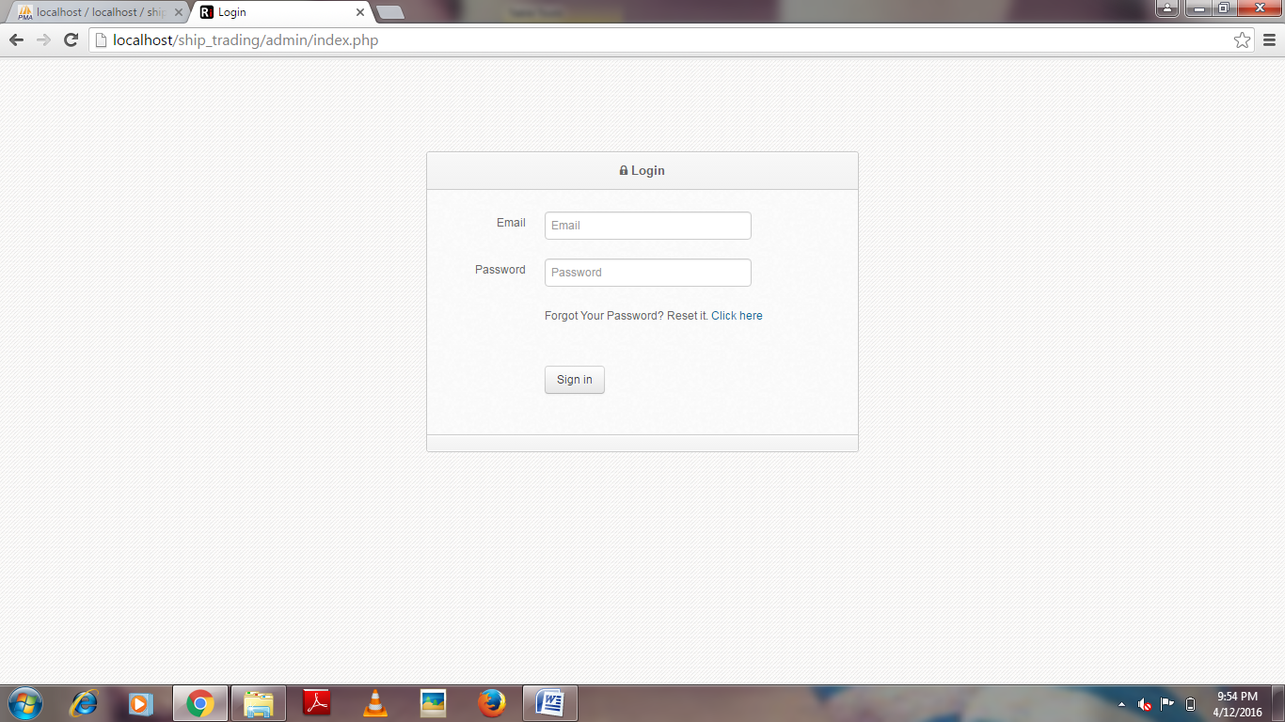

**7. SCREEN SHOTS**

**7.1 Login Page**

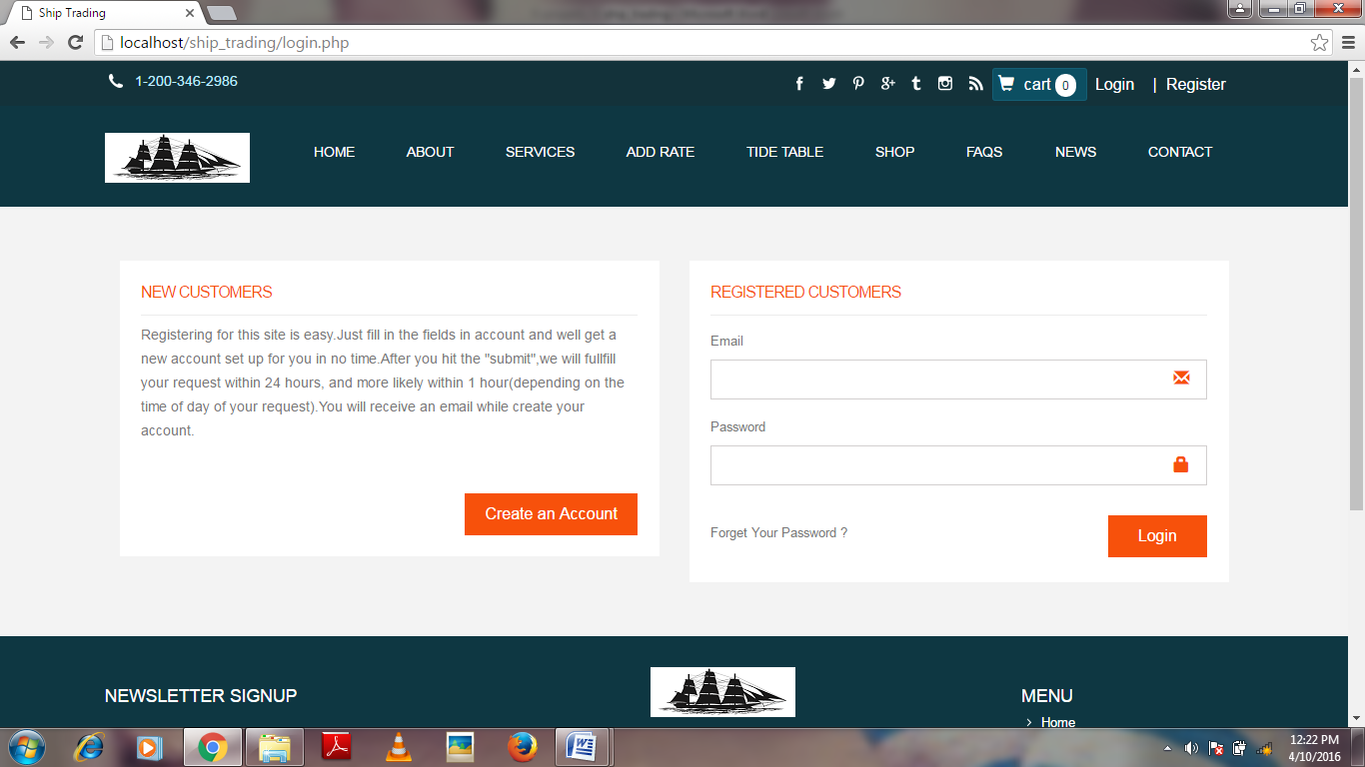

**Fig 7.1 Login page**

**7.2 Register Page**

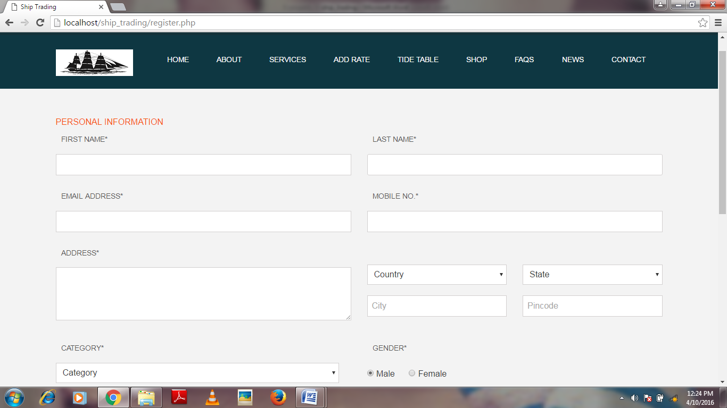

**Fig 7.2 Register page**

**7.3 Home Page**

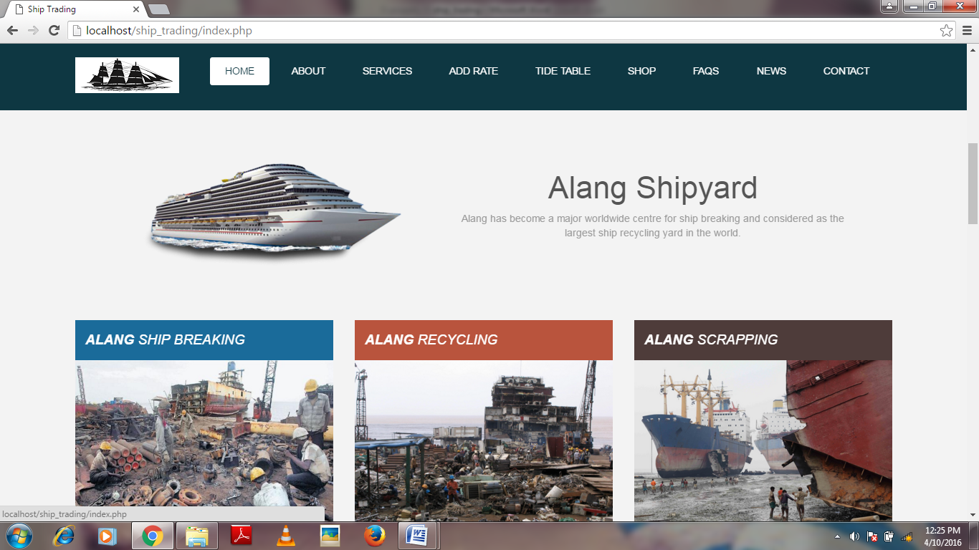

**Fig 7.3 Home page**

**7.4 Services Page**

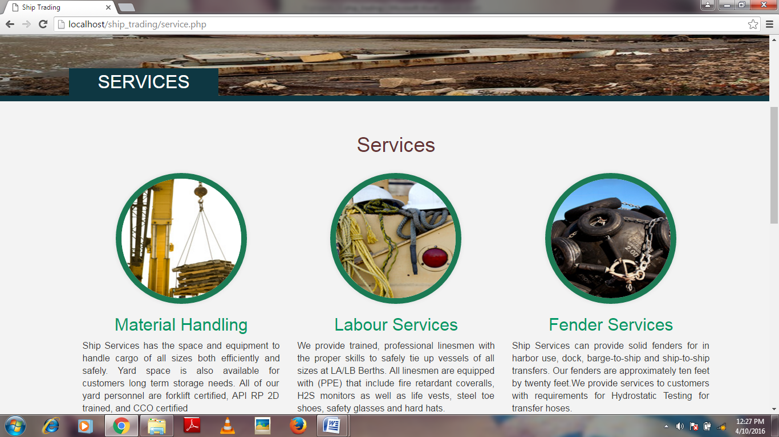

**Fig 7.4 Services page**

**7.5 Add Rate Page**

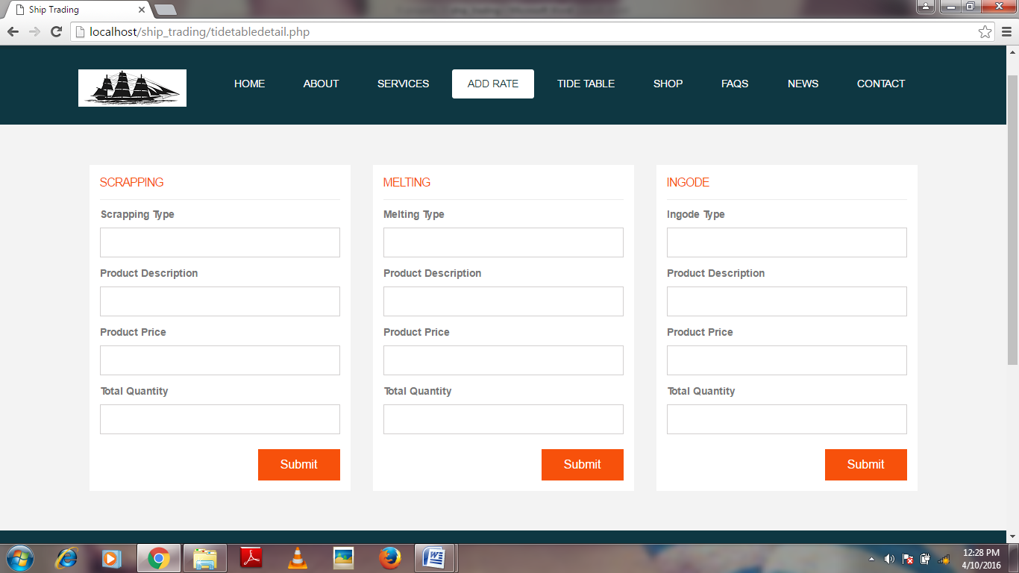

**Fig 7.5 Add rate page**

**7.6 Tide-table Page**

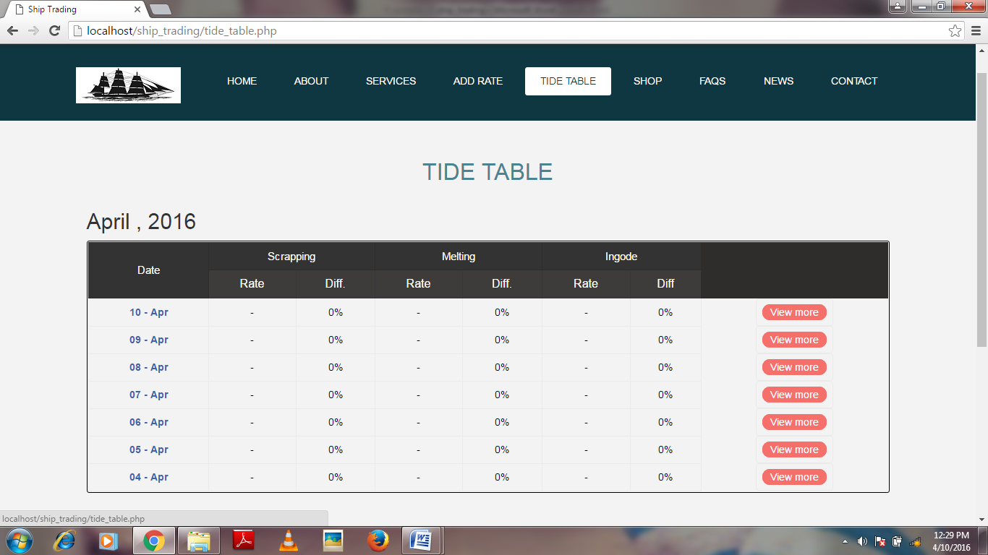

**Fig 7.6 Tide-table page**

**7.7 Shop Page**

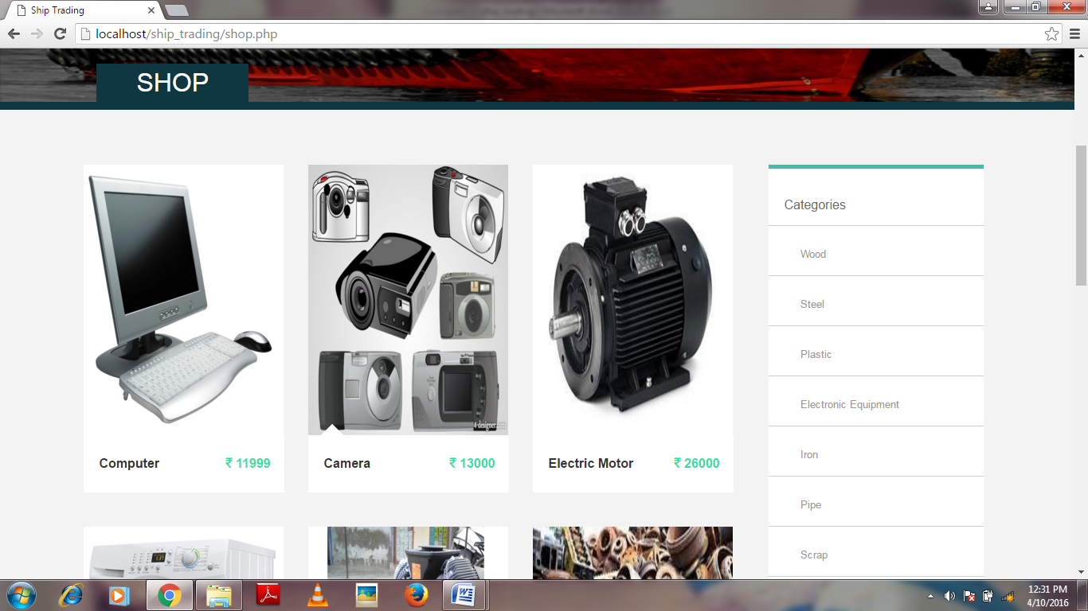

**Fig 7.7 Shop page**

**7.8 Faqs Page**

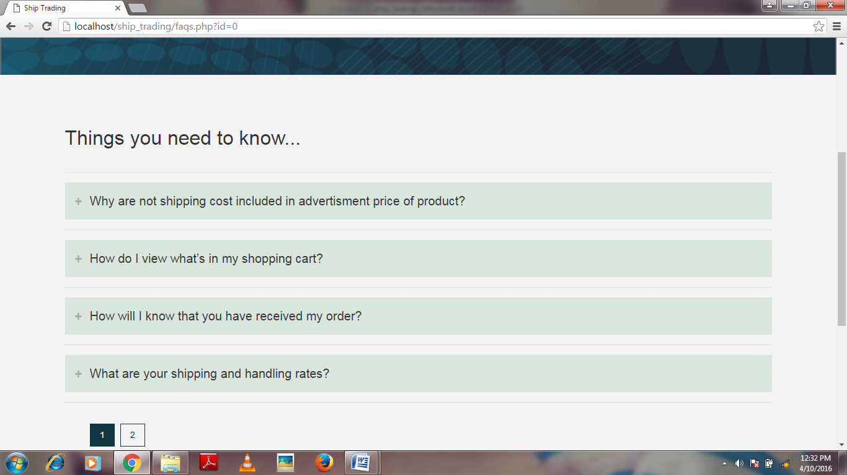

**Fig 7.8 Faqs page**

**7.9 News Page**

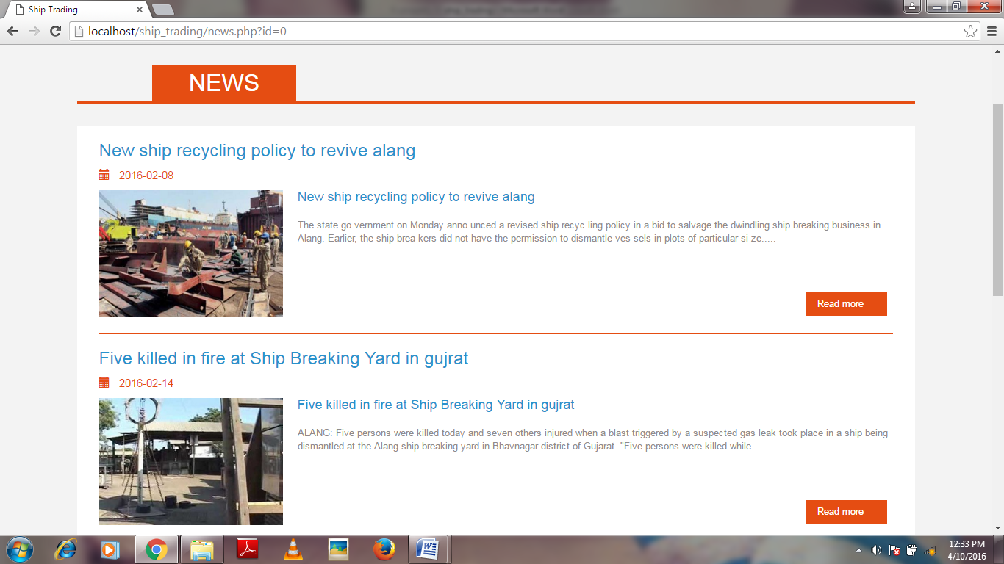

**Fig 7.9 News page**

**7.10 Contact Page**

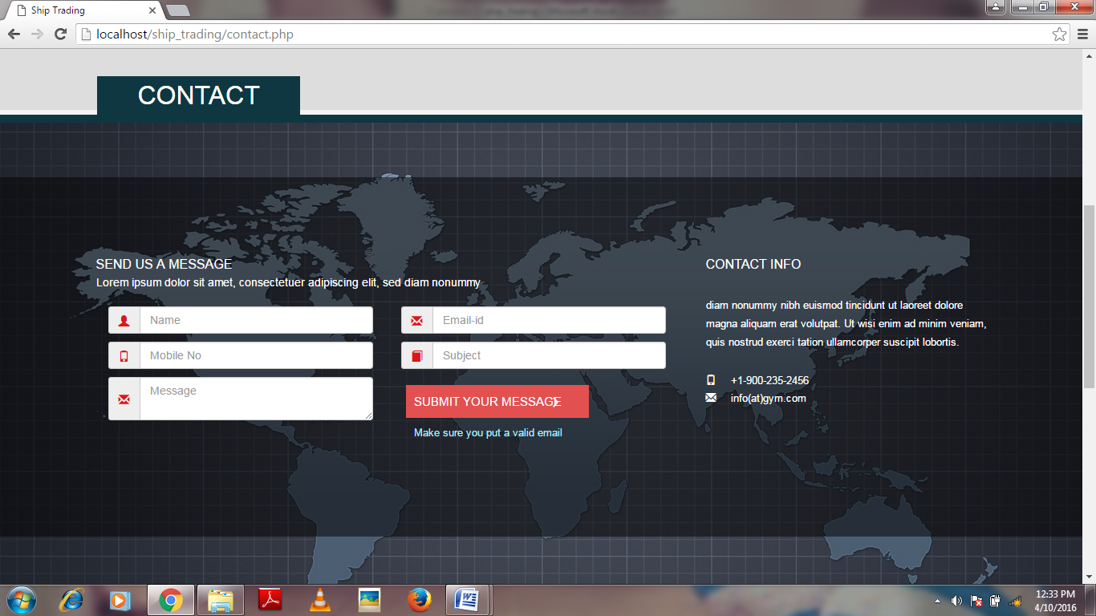

**Fig 7.10 contact page**

**7.11 Buy Page**

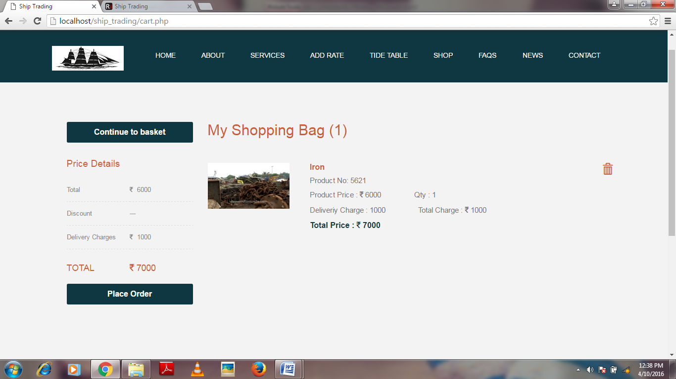

**Fig 7.11 Buy page**

**7.12 Order Review Page**

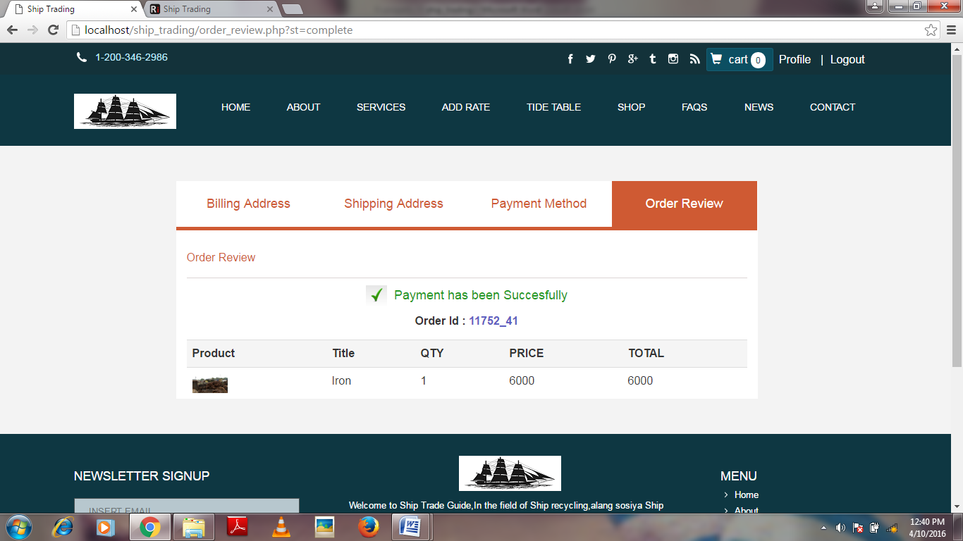

**Fig 7.12 Order Review page**

**8. APPLICATION FEATURES**

**It has many features such as:**

* Easy for user to write and upload post and edit them later if needed.
* Allows link to other sections in a websites. –e.g. a contact us page or further information.
* User can post from anywhere in the world.
* The availability to assign multiple tags to any post and the able to display archive by category.
* As the best this systems are free open source there should be no software purchasing costs, running costs, upgrade costs or license free.

**The main purpose of applications are:**

* For each buyer to learn about and search the property of their choosing.
* For each buyer and seller to develop a online global – work community from whom they sale or buy the materials.

**9. LIMITATIONS AND ENHANCEMENTS**

**9.1 Limitation:**

* Organizations which is registered only registered user.
* Use only when Internet connections.
* This system work through the main in website.
* This system for any user who buy the material from Alang.

**9.2 Enhancements:**

* Supplier can sell the materials to the users.
* Suppliers and employee are set status about its work.
* Employee put and share his/her blogs.

**10. CONCLUSIONS AND REFERENCIES**

**10.1 Conclusion:**

* Ur websites gives opportunity to our employees to get all the details of work online so that the time and money can be saved.
* If the employees invited by organizations and registered than they will be used this system.

Every website work does not matter project or any other project could not be the result of sole effort; even though, developer team consists one member. We think success of any project does not depend only on better software development skills, but also, deal to listen and help the users. Only user interaction at development phase can give you an idea to fulfill their requirements. Because, up to development or host the website is for developer, but then after it is for users .we experienced that do make the website for users not for fame of being better programmer or web developer. Ultimately, users appraise your efforts not your peers.

No project can be teamed as perfect in real sense and there always remains scope for further improvement and so that helps to develop a new points and validation related to the projects and which give us more knowledge and helps us to create new version.

We personally think that this project has helped us to understand lot more about our subject. We have tried to make our project the best but still we are lacking somewhere or the other. We will try to improve the next time whenever we are given an opportunity.

**10.2 References:**

* [www.google.com](http://www.google.com)
* [www.w3schools.com](http://www.w3schools.com)
* [www.theeasylearnacademy.com](http://www.theeasylearnacademy.com)